FILE 2 – COMPLEXITY COMPARISON TABLE
LAB 2 – Algorithm Performance Measurement and Benchmarking Tool
Design and Analysis of Algorithms Laboratory

Student Name | Yashvi Sahu
Roll No. | 2401201010
Course / Semester | BCA / 5th
Subject | Design and Analysis of Algorithms

Question 5 – Complexity Analysis Module
The following table reproduces the theoretical complexity classification used in the notebook.
Algorithm | Time Complexity | Space Complexity
Linear Search | O(n) | O(1)
Binary Search | O(log n) | O(1)
Recursive Factorial | O(n) | O(n)
Iterative Factorial | O(n) | O(1)
Single Loop | O(n) | O(1)
Nested Loop | O(n²) | O(1)

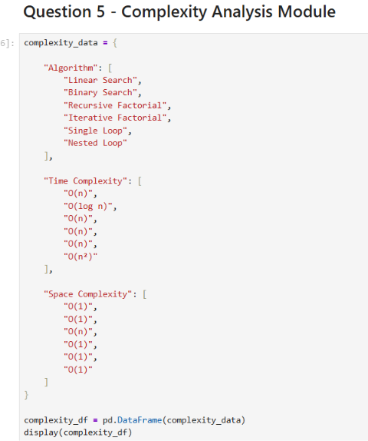
Q5 – Complexity analysis module
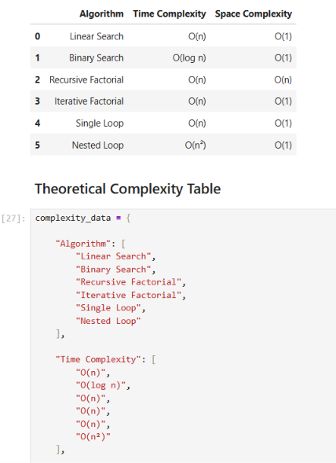
Q5 – Theoretical complexity table
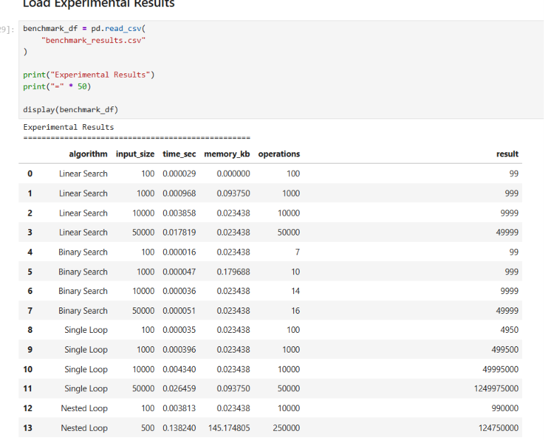
Q5 – Experimental benchmark results loaded from CSV
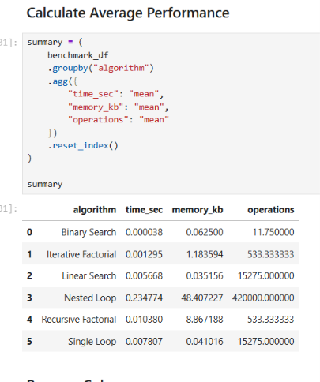
Q5 – Average performance calculation
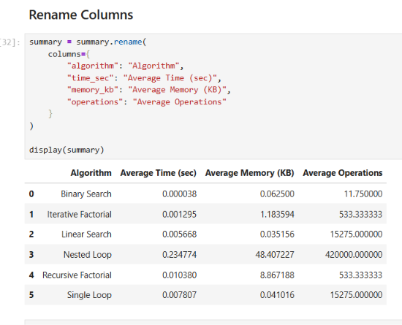
Q5 – Renamed average-performance columns
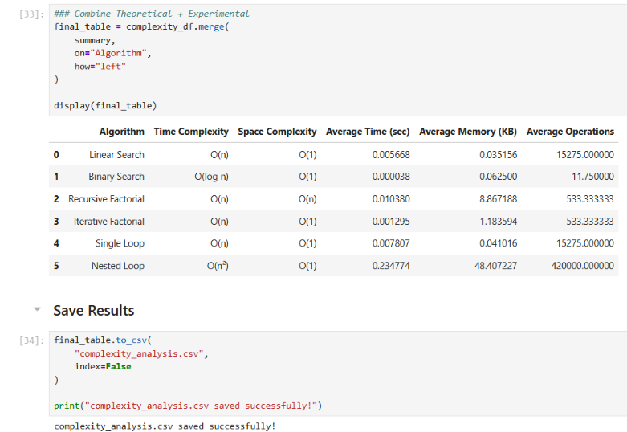
Q5 – Combined theoretical and experimental analysis table

Observed Average Performance
Algorithm | Average Time (sec) | Average Memory (KB) | Average Operations
Binary Search | 0.000038 | 0.062500 | 11.750000
Iterative Factorial | 0.001295 | 1.183594 | 533.333333
Linear Search | 0.005668 | 0.035156 | 15275.000000
Nested Loop | 0.234774 | 48.407227 | 420000.000000
Recursive Factorial | 0.010380 | 8.867188 | 533.333333
Single Loop | 0.007807 | 0.041016 | 15275.000000

Combined Interpretation
- Linear Search shows approximately linear growth in the number of comparisons as input size increases.
- Binary Search keeps the comparison count small and grows logarithmically for the sorted dataset.
- Recursive Factorial has the same O(n) time classification as Iterative Factorial but uses additional call-stack space.
- Nested Loop performs many more operations than a single loop, matching its O(n²) theoretical time growth.
- The measured values are experimental observations from the submitted notebook run; small timing and memory differences can vary between runs.

https://github.com/YashviSahu555/DAA-Lab-File-2

